Banking Database – Complete MySQL Implementation
We will design a relational banking database using MySQL 8.0+, suitable for a Java JDBC-based Banking CLI application and future Spring Boot microservices implementation.
The database will support:
- Customer registration and login.
- Multiple accounts per customer.
- Savings, Current, Loan and Deposit accounts.
- Deposit, Withdrawal, Maturity and Fund Transfer transactions.
- Login activity tracking.
- Transaction auditing.
- Monthly Average Balance (MAB) calculation.
- Quarterly interest calculation and automatic credit to Savings Accounts.
- Primary keys, foreign keys, unique constraints, check constraints and NOT NULL constraints.
- Stored procedures, functions and triggers.

1. Database architecture

Business rules
Entity | Business rule
Customer | One customer can own multiple accounts
Account | Each account belongs to one customer
Savings Account | Eligible for quarterly interest
Current Account | Supports deposits and withdrawals
Loan Account | Tracks loan-related balances
Deposit Account | Supports maturity transactions
Transaction | Belongs to an account
Fund Transfer | Has a source and destination account
Login Audit | Records successful and failed login attempts
Transaction Audit | Records transaction insertions, modifications and deletions
Daily Balance | Stores end-of-day account balances for MAB calculation

Account types
- SAVINGS
- CURRENT
- LOAN
- DEPOSIT

Transaction types
- DEPOSIT
- WITHDRAW
- MATURITY
- FUND_TRANSFER
- INTEREST_CREDIT
INTEREST_CREDIT is an additional internal transaction type required to maintain a complete financial ledger when quarterly interest is credited.

2. Entity Relationship Diagram (ERD)
Top SQL Projects: Beginners to Advanced with Source Code
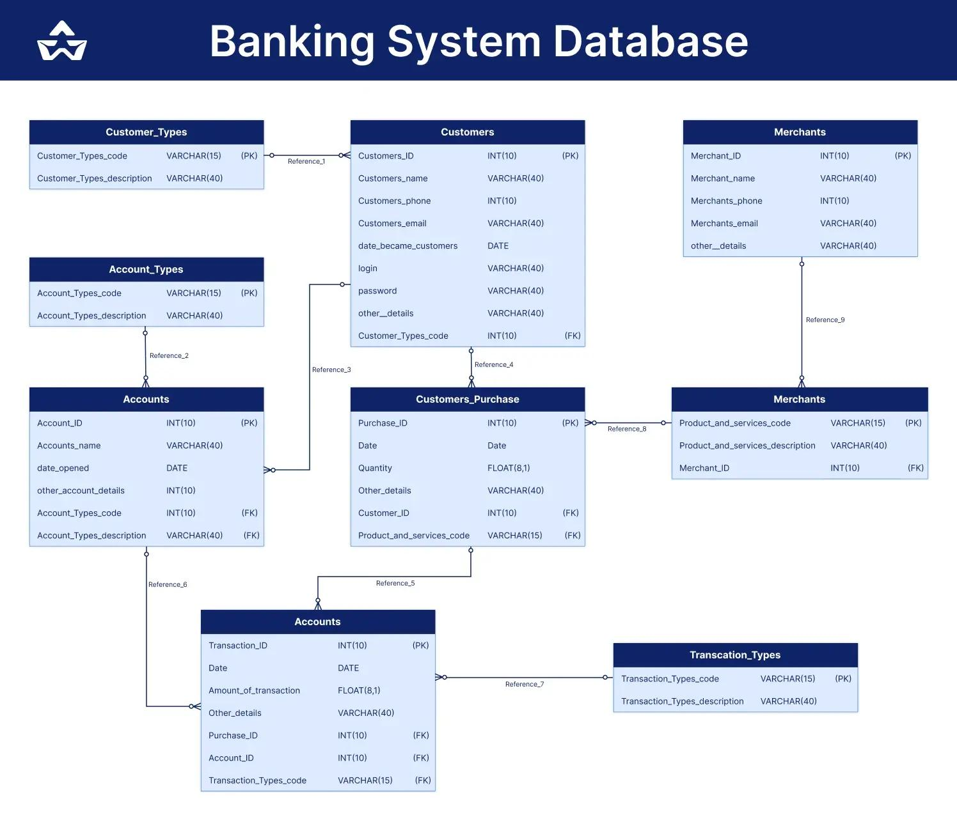
bosscoderacademy.com
The following Mermaid ER diagram represents the actual database relationships:
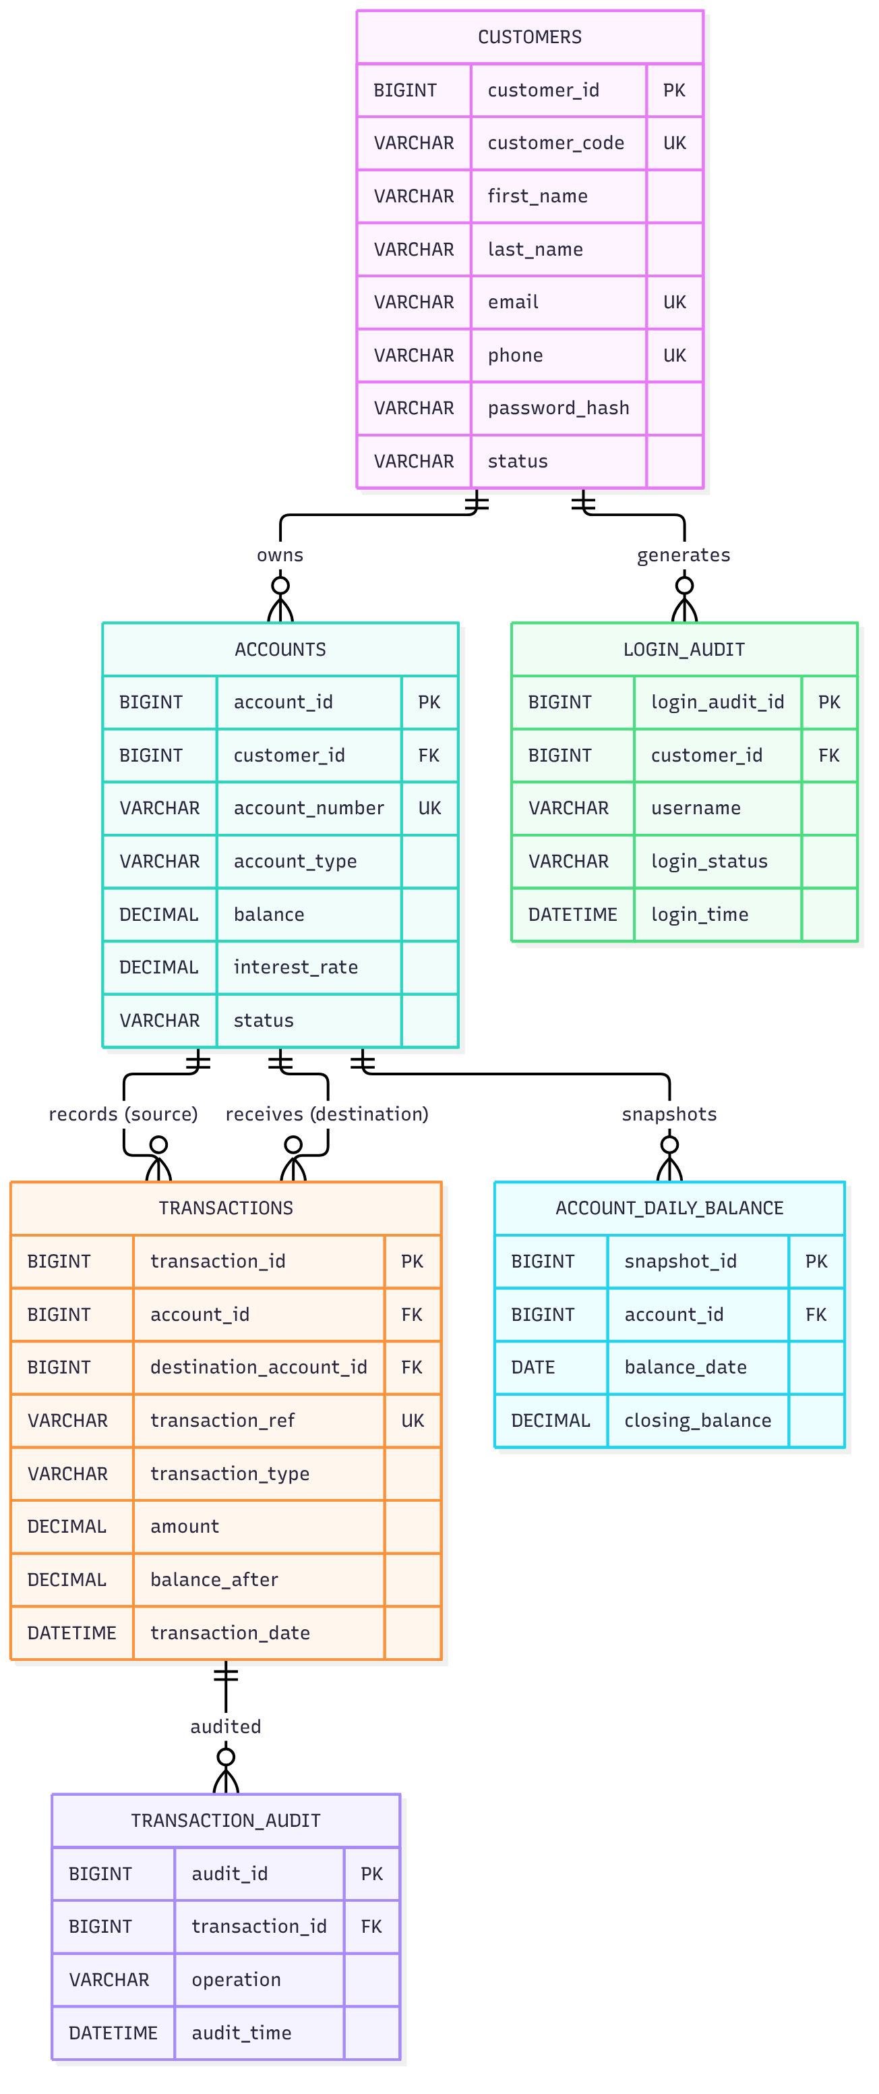
The additional ACCOUNT_DAILY_BALANCE table is important. Without daily balance snapshots, calculating an accurate monthly average balance from only the current account balance will not be possible.

3. Complete SQL implementation
The following script is organized in execution order. You can save it as banking_database.sql and execute it using MySQL Workbench or the MySQL command-line client.

3.1 Create database
DROP DATABASE IF EXISTS banking_db;

CREATE DATABASE banking_db;

USE banking_db;

SET FOREIGN_KEY_CHECKS = 1;

3.2 Customers table
Stores customer registration and authentication details.
CREATE TABLE customers (
customer_id BIGINT AUTO_INCREMENT PRIMARY KEY,

customer_code VARCHAR(20) NOT NULL UNIQUE,

first_name VARCHAR(50) NOT NULL,
last_name VARCHAR(50) NOT NULL,

email VARCHAR(100) NOT NULL UNIQUE,
phone VARCHAR(15) NOT NULL UNIQUE,

password_hash VARCHAR(255) NOT NULL,

date_of_birth DATE,

address VARCHAR(255),

status ENUM('ACTIVE', 'INACTIVE', 'BLOCKED')
NOT NULL DEFAULT 'ACTIVE',

created_at TIMESTAMP DEFAULT CURRENT_TIMESTAMP,
updated_at TIMESTAMP DEFAULT CURRENT_TIMESTAMP
ON UPDATE CURRENT_TIMESTAMP,

CONSTRAINT chk_customer_dob
CHECK (date_of_birth IS NULL OR date_of_birth < CURRENT_DATE)
);
Important: Store only securely hashed passwords, preferably using BCrypt or Argon2 in your Java application. Never store plain-text passwords.

3.3 Accounts table
A customer can have multiple accounts of different types.
CREATE TABLE accounts (
account_id BIGINT AUTO_INCREMENT PRIMARY KEY,

customer_id BIGINT NOT NULL,

account_number VARCHAR(20) NOT NULL UNIQUE,

account_type ENUM(
'SAVINGS',
'CURRENT',
'LOAN',
'DEPOSIT'
) NOT NULL,

balance DECIMAL(15,2) NOT NULL DEFAULT 0.00,

interest_rate DECIMAL(5,2) NOT NULL DEFAULT 0.00,

minimum_balance DECIMAL(15,2) NOT NULL DEFAULT 0.00,

opening_date DATE NOT NULL,

maturity_date DATE NULL,

status ENUM(
'ACTIVE',
'INACTIVE',
'CLOSED',
'FROZEN'
) NOT NULL DEFAULT 'ACTIVE',

created_at TIMESTAMP DEFAULT CURRENT_TIMESTAMP,

CONSTRAINT fk_accounts_customer
FOREIGN KEY (customer_id)
REFERENCES customers(customer_id),

CONSTRAINT chk_account_balance
CHECK (balance >= 0),

CONSTRAINT chk_interest_rate
CHECK (interest_rate BETWEEN 0 AND 100),

CONSTRAINT chk_minimum_balance
CHECK (minimum_balance >= 0),

CONSTRAINT chk_maturity_date
CHECK (
maturity_date IS NULL
OR maturity_date >= opening_date
),

INDEX idx_accounts_customer (customer_id),
INDEX idx_accounts_type (account_type)
);
Interest rate examples:
Account type | Sample annual interest
Savings | 4.00%
Current | 0.00%
Loan | 9.00%
Deposit | 7.00%
These are illustrative training values, not actual bank rates.

3.4 Transactions table
This table maintains the financial transaction records.
CREATE TABLE transactions (
transaction_id BIGINT AUTO_INCREMENT PRIMARY KEY,

transaction_ref VARCHAR(40) NOT NULL UNIQUE,

account_id BIGINT NOT NULL,

destination_account_id BIGINT NULL,

transaction_type ENUM(
'DEPOSIT',
'WITHDRAW',
'MATURITY',
'FUND_TRANSFER',
'INTEREST_CREDIT'
) NOT NULL,

amount DECIMAL(15,2) NOT NULL,

balance_before DECIMAL(15,2) NOT NULL,

balance_after DECIMAL(15,2) NOT NULL,

description VARCHAR(255),

transaction_date TIMESTAMP NOT NULL DEFAULT CURRENT_TIMESTAMP,

status ENUM(
'SUCCESS',
'FAILED',
'PENDING'
) NOT NULL DEFAULT 'SUCCESS',

CONSTRAINT fk_transactions_account
FOREIGN KEY (account_id)
REFERENCES accounts(account_id),

CONSTRAINT fk_transactions_destination
FOREIGN KEY (destination_account_id)
REFERENCES accounts(account_id),

CONSTRAINT chk_transaction_amount
CHECK (amount > 0),

CONSTRAINT chk_transaction_balances
CHECK (
balance_before >= 0
AND balance_after >= 0
),

CONSTRAINT chk_transfer_destination
CHECK (
(transaction_type = 'FUND_TRANSFER'
AND destination_account_id IS NOT NULL
AND destination_account_id <> account_id)
OR
(transaction_type <> 'FUND_TRANSFER'
AND destination_account_id IS NULL)
),

INDEX idx_transaction_account (account_id),
INDEX idx_transaction_date (transaction_date),
INDEX idx_transaction_type (transaction_type)
);
Fund transfer design: One transaction record represents the transfer. The source and destination account IDs are stored in the same row. Both account balances are updated atomically.

3.5 Login audit table
Tracks customer login activities.
CREATE TABLE login_audit (
login_audit_id BIGINT AUTO_INCREMENT PRIMARY KEY,

customer_id BIGINT NULL,

username VARCHAR(100) NOT NULL,

login_status ENUM(
'SUCCESS',
'FAILED',
'LOCKED',
'LOGOUT'
) NOT NULL,

ip_address VARCHAR(45),

device_info VARCHAR(255),

failure_reason VARCHAR(255),

login_time TIMESTAMP NOT NULL DEFAULT CURRENT_TIMESTAMP,

CONSTRAINT fk_login_customer
FOREIGN KEY (customer_id)
REFERENCES customers(customer_id)
ON DELETE SET NULL,

INDEX idx_login_customer (customer_id),
INDEX idx_login_time (login_time),
INDEX idx_login_status (login_status)
);
customer_id is nullable because an unsuccessful login may involve a username that does not exist.

3.6 Transaction audit table
Maintains a record of transaction data changes.
CREATE TABLE transaction_audit (
audit_id BIGINT AUTO_INCREMENT PRIMARY KEY,

transaction_id BIGINT NOT NULL,

operation ENUM(
'INSERT',
'UPDATE',
'DELETE'
) NOT NULL,

old_amount DECIMAL(15,2),

new_amount DECIMAL(15,2),

old_status VARCHAR(20),

new_status VARCHAR(20),

changed_by VARCHAR(100),

audit_time TIMESTAMP DEFAULT CURRENT_TIMESTAMP,

CONSTRAINT fk_audit_transaction
FOREIGN KEY (transaction_id)
REFERENCES transactions(transaction_id),

INDEX idx_audit_transaction (transaction_id),
INDEX idx_audit_time (audit_time)
);

3.7 Account daily balance table
This additional table stores the end-of-day balance for each account.
CREATE TABLE account_daily_balance (
snapshot_id BIGINT AUTO_INCREMENT PRIMARY KEY,

account_id BIGINT NOT NULL,

balance_date DATE NOT NULL,

closing_balance DECIMAL(15,2) NOT NULL,

created_at TIMESTAMP DEFAULT CURRENT_TIMESTAMP,

CONSTRAINT fk_daily_balance_account
FOREIGN KEY (account_id)
REFERENCES accounts(account_id),

CONSTRAINT chk_closing_balance
CHECK (closing_balance >= 0),

CONSTRAINT uk_account_balance_date
UNIQUE (account_id, balance_date),

INDEX idx_balance_date (balance_date)
);

4. Stored functions

4.1 Function – Calculate monthly average balance
Monthly Average Balance is calculated using the daily closing balances.
\[ MAB = \frac{\sum \text{Daily Closing Balances}}{\text{Number of Days in Month}} \]
Example:
Date | Closing balance
1st | ₹10,000
2nd | ₹12,000
3rd | ₹14,000
4th | ₹12,000
5th | ₹12,000
For a five-day illustrative period:
\[ MAB = \frac{10000+12000+14000+12000+12000}{5} \]
Original amountsEqual shares101010
\(\bar{x} = \frac{10 + 10 + 10}{3} = \frac{30}{3} = 10\)
x̄ is the arithmetic mean (simple average)
\(x_1\)
\(x_2\)
\(x_3\)
Remove valueAdd value
Give feedback
The production calculation uses all calendar days in the month, not just days with transactions.
DELIMITER $$

CREATE FUNCTION fn_monthly_average_balance(
p_account_id BIGINT,
p_year INT,
p_month INT
)
RETURNS DECIMAL(15,2)
READS SQL DATA
BEGIN

DECLARE v_total_balance DECIMAL(20,2) DEFAULT 0;
DECLARE v_days INT DEFAULT 0;
DECLARE v_result DECIMAL(15,2) DEFAULT 0;

SELECT
COALESCE(SUM(closing_balance), 0),
COUNT(*)
INTO
v_total_balance,
v_days
FROM account_daily_balance
WHERE account_id = p_account_id
AND YEAR(balance_date) = p_year
AND MONTH(balance_date) = p_month;

SET v_days = DAY(
LAST_DAY(
STR_TO_DATE(
CONCAT(p_year, '-', p_month, '-01'),
'%Y-%m-%d'
)
)
);

IF (
SELECT COUNT(*)
FROM account_daily_balance
WHERE account_id = p_account_id
AND balance_date >= STR_TO_DATE(
CONCAT(p_year, '-', LPAD(p_month, 2, '0'), '-01'),
'%Y-%m-%d'
)
AND balance_date <= LAST_DAY(
STR_TO_DATE(
CONCAT(p_year, '-', LPAD(p_month, 2, '0'), '-01'),
'%Y-%m-%d'
)
)
) < v_days THEN

SIGNAL SQLSTATE '45000'
SET MESSAGE_TEXT =
'Incomplete daily balance snapshots for the month';

END IF;

SET v_result = v_total_balance / v_days;

RETURN ROUND(v_result, 2);

END$$

DELIMITER ;

4.2 Function – Calculate quarterly savings interest
Interest is calculated monthly and credited once every quarter.
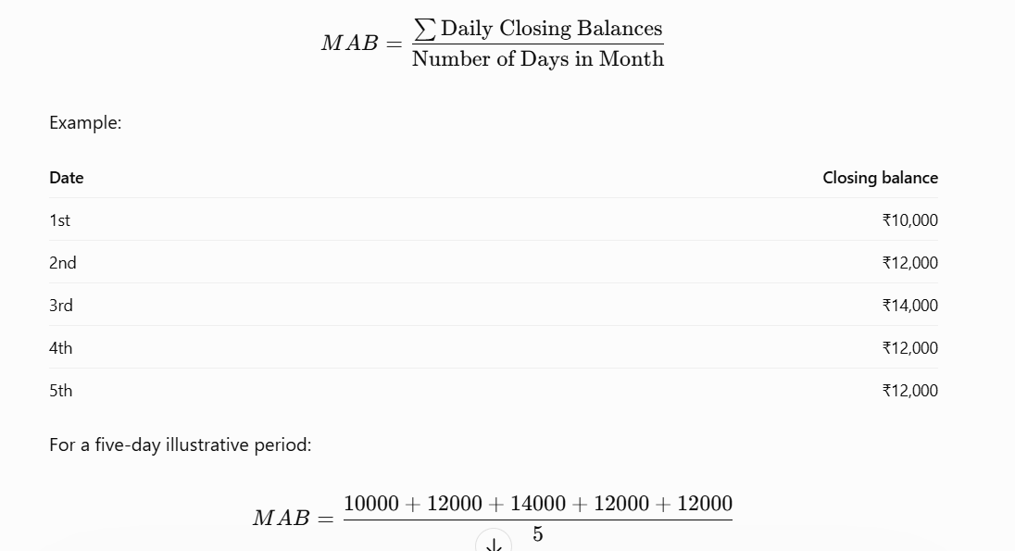
For this implementation:
\[ \text{Monthly Interest} = MAB \times \frac{\text{Annual Rate}}{100 \times 12} \]
\[ \text{Quarterly Interest} = \sum_{m=1}^{3} \text{Monthly Interest}_m \]
Example:
- Annual savings interest rate = 4%
- January MAB = ₹100,000
- February MAB = ₹120,000
- March MAB = ₹110,000
\[ I = (100000+120000+110000)\times\frac{4}{1200} \]
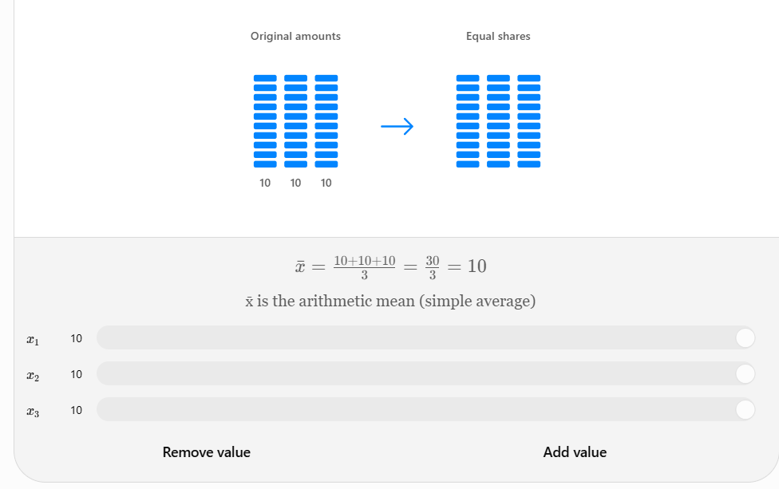
Quarterly interest = ₹1,100.
DELIMITER $$

CREATE FUNCTION fn_quarterly_interest(
p_account_id BIGINT,
p_year INT,
p_quarter INT
)
RETURNS DECIMAL(15,2)
READS SQL DATA
BEGIN

DECLARE v_rate DECIMAL(5,2);
DECLARE v_total_interest DECIMAL(20,4) DEFAULT 0;

DECLARE v_month INT;
DECLARE v_start_month INT;

SELECT interest_rate
INTO v_rate
FROM accounts
WHERE account_id = p_account_id
AND account_type = 'SAVINGS';

IF v_rate IS NULL THEN
SIGNAL SQLSTATE '45000'
SET MESSAGE_TEXT =
'Account not found or account is not a savings account';
END IF;

IF p_quarter NOT BETWEEN 1 AND 4 THEN
SIGNAL SQLSTATE '45000'
SET MESSAGE_TEXT = 'Invalid quarter';
END IF;

SET v_start_month = (p_quarter - 1) * 3 + 1;
SET v_month = v_start_month;

WHILE v_month < v_start_month + 3 DO

SET v_total_interest =
v_total_interest +
(
fn_monthly_average_balance(
p_account_id,
p_year,
v_month
) * v_rate / 1200
);

SET v_month = v_month + 1;

END WHILE;

RETURN ROUND(v_total_interest, 2);

END$$

DELIMITER ;

5. Triggers for transaction auditing
These triggers automatically populate transaction_audit.

5.1 AFTER INSERT trigger
DELIMITER $$

CREATE TRIGGER trg_transaction_after_insert
AFTER INSERT ON transactions
FOR EACH ROW
BEGIN

INSERT INTO transaction_audit (
transaction_id,
operation,
new_amount,
new_status,
changed_by
)
VALUES (
NEW.transaction_id,
'INSERT',
NEW.amount,
NEW.status,
CURRENT_USER()
);

END$$

DELIMITER ;

5.2 AFTER UPDATE trigger
DELIMITER $$

CREATE TRIGGER trg_transaction_after_update
AFTER UPDATE ON transactions
FOR EACH ROW
BEGIN

INSERT INTO transaction_audit (
transaction_id,
operation,
old_amount,
new_amount,
old_status,
new_status,
changed_by
)
VALUES (
NEW.transaction_id,
'UPDATE',
OLD.amount,
NEW.amount,
OLD.status,
NEW.status,
CURRENT_USER()
);

END$$

DELIMITER ;

5.3 AFTER DELETE trigger
DELIMITER $$

CREATE TRIGGER trg_transaction_after_delete
AFTER DELETE ON transactions
FOR EACH ROW
BEGIN

INSERT INTO transaction_audit (
transaction_id,
operation,
old_amount,
old_status,
changed_by
)
VALUES (
OLD.transaction_id,
'DELETE',
OLD.amount,
OLD.status,
CURRENT_USER()
);

END$$

DELIMITER ;
Production consideration: The current foreign key intentionally prevents deletion of transactions that have audit records. For a production banking system, use immutable ledger records and reversal transactions instead of deleting financial transactions. The delete trigger is included for demonstrating auditing.

6. Stored procedures

6.1 Procedure – Deposit, withdrawal and fund transfer
This is the central transaction-processing procedure.
It handles:
- Deposit: Increase account balance.
- Withdrawal: Decrease account balance.
- Maturity: Credit maturity proceeds.
- Fund transfer: Debit source account and credit destination account.
- Interest credit: Credit savings interest.
It also uses database transactions and row-level locking to prevent concurrent balance updates from overwriting each other.
DELIMITER $$

CREATE PROCEDURE sp_process_transaction(
IN p_transaction_ref VARCHAR(40),
IN p_account_id BIGINT,
IN p_destination_account_id BIGINT,
IN p_transaction_type VARCHAR(30),
IN p_amount DECIMAL(15,2),
IN p_description VARCHAR(255)
)
BEGIN

DECLARE v_balance DECIMAL(15,2);
DECLARE v_destination_balance DECIMAL(15,2);

DECLARE v_new_balance DECIMAL(15,2);
DECLARE v_account_type VARCHAR(20);
DECLARE v_account_status VARCHAR(20);

DECLARE v_destination_status VARCHAR(20);

DECLARE EXIT HANDLER FOR SQLEXCEPTION
BEGIN
ROLLBACK;
RESIGNAL;
END;

IF p_amount <= 0 THEN
SIGNAL SQLSTATE '45000'
SET MESSAGE_TEXT = 'Transaction amount must be positive';
END IF;

START TRANSACTION;

SELECT balance, account_type, status
INTO v_balance, v_account_type, v_account_status
FROM accounts
WHERE account_id = p_account_id
FOR UPDATE;

IF v_account_status <> 'ACTIVE' THEN
SIGNAL SQLSTATE '45000'
SET MESSAGE_TEXT = 'Source account is not active';
END IF;

SET v_new_balance = v_balance;

CASE p_transaction_type

WHEN 'DEPOSIT' THEN

SET v_new_balance = v_balance + p_amount;

WHEN 'MATURITY' THEN

IF v_account_type <> 'DEPOSIT' THEN
SIGNAL SQLSTATE '45000'
SET MESSAGE_TEXT =
'Maturity credit requires a deposit account';
END IF;

SET v_new_balance = v_balance + p_amount;

WHEN 'INTEREST_CREDIT' THEN

IF v_account_type <> 'SAVINGS' THEN
SIGNAL SQLSTATE '45000'
SET MESSAGE_TEXT =
'Interest credit requires a savings account';
END IF;

SET v_new_balance = v_balance + p_amount;

WHEN 'WITHDRAW' THEN

IF v_balance < p_amount THEN
SIGNAL SQLSTATE '45000'
SET MESSAGE_TEXT = 'Insufficient balance';
END IF;

IF v_account_type = 'SAVINGS'
AND v_balance - p_amount < (
SELECT minimum_balance
FROM accounts
WHERE account_id = p_account_id
) THEN

SIGNAL SQLSTATE '45000'
SET MESSAGE_TEXT =
'Minimum savings balance requirement violated';

END IF;

SET v_new_balance = v_balance - p_amount;

WHEN 'FUND_TRANSFER' THEN

IF p_destination_account_id IS NULL
OR p_destination_account_id = p_account_id THEN

SIGNAL SQLSTATE '45000'
SET MESSAGE_TEXT = 'Invalid destination account';

END IF;

IF v_balance < p_amount THEN
SIGNAL SQLSTATE '45000'
SET MESSAGE_TEXT = 'Insufficient transfer balance';
END IF;

SELECT balance, status
INTO v_destination_balance, v_destination_status
FROM accounts
WHERE account_id = p_destination_account_id
FOR UPDATE;

IF v_destination_status <> 'ACTIVE' THEN
SIGNAL SQLSTATE '45000'
SET MESSAGE_TEXT =
'Destination account is not active';
END IF;

SET v_new_balance = v_balance - p_amount;

UPDATE accounts
SET balance = v_new_balance
WHERE account_id = p_account_id;

UPDATE accounts
SET balance = balance + p_amount
WHERE account_id = p_destination_account_id;

ELSE

SIGNAL SQLSTATE '45000'
SET MESSAGE_TEXT = 'Invalid transaction type';

END CASE;

IF p_transaction_type <> 'FUND_TRANSFER' THEN

UPDATE accounts
SET balance = v_new_balance
WHERE account_id = p_account_id;

END IF;

INSERT INTO transactions (
transaction_ref,
account_id,
destination_account_id,
transaction_type,
amount,
balance_before,
balance_after,
description,
status
)
VALUES (
p_transaction_ref,
p_account_id,
IF(
p_transaction_type = 'FUND_TRANSFER',
p_destination_account_id,
NULL
),
p_transaction_type,
p_amount,
v_balance,
v_new_balance,
p_description,
'SUCCESS'
);

COMMIT;

END$$

DELIMITER ;
Example execution:
-- Deposit ₹5,000
CALL sp_process_transaction(
'TXN-1001',
1,
NULL,
'DEPOSIT',
5000,
'Cash deposit'
);

-- Withdraw ₹1,000
CALL sp_process_transaction(
'TXN-1002',
1,
NULL,
'WITHDRAW',
1000,
'ATM withdrawal'
);

-- Transfer ₹2,000 from account 1 to account 2
CALL sp_process_transaction(
'TXN-1003',
1,
2,
'FUND_TRANSFER',
2000,
'Transfer to another account'
);

-- Deposit maturity proceeds
CALL sp_process_transaction(
'TXN-1004',
4,
NULL,
'MATURITY',
50000,
'Fixed deposit maturity proceeds'
);
The procedure is suitable as a learning implementation. Before production use, strengthen transfer locking by acquiring both account locks in ascending account ID order, enforce transaction permissions and idempotency, and use a consistent account-level transaction policy.

6.2 Procedure – Record daily account balances
This procedure captures the end-of-day balance.
It should be scheduled to run once per day after the bank's daily posting cutoff.
DELIMITER $$

CREATE PROCEDURE sp_capture_daily_balances(
IN p_balance_date DATE
)
BEGIN

INSERT INTO account_daily_balance (
account_id,
balance_date,
closing_balance
)
SELECT
account_id,
p_balance_date,
balance
FROM accounts
WHERE status IN ('ACTIVE', 'FROZEN')

ON DUPLICATE KEY UPDATE
closing_balance = VALUES(closing_balance);

END$$

DELIMITER ;
Example:
CALL sp_capture_daily_balances(CURRENT_DATE);
This is an end-of-day snapshot. In a real banking environment, the cutoff time and backdated transaction policy must be defined carefully.

6.3 Procedure – Credit quarterly interest
This procedure:
- Finds all active savings accounts.
- Calculates monthly average balances for the three months.
- Calculates quarterly interest.
- Credits interest to the savings account.
- Inserts an interest transaction.
- Uses a unique transaction reference to prevent duplicate quarterly credits.
DELIMITER $$

CREATE PROCEDURE sp_credit_quarterly_interest(
IN p_year INT,
IN p_quarter INT
)
BEGIN

DECLARE v_account_id BIGINT;
DECLARE v_interest DECIMAL(15,2);
DECLARE v_transaction_ref VARCHAR(40);

DECLARE v_done INT DEFAULT 0;

DECLARE cur_accounts CURSOR FOR
SELECT account_id
FROM accounts
WHERE account_type = 'SAVINGS'
AND status = 'ACTIVE';

DECLARE CONTINUE HANDLER FOR NOT FOUND
SET v_done = 1;

IF p_quarter NOT BETWEEN 1 AND 4 THEN
SIGNAL SQLSTATE '45000'
SET MESSAGE_TEXT = 'Quarter must be between 1 and 4';
END IF;

OPEN cur_accounts;

interest_loop: LOOP

FETCH cur_accounts INTO v_account_id;

IF v_done = 1 THEN
LEAVE interest_loop;
END IF;

SET v_interest = fn_quarterly_interest(
v_account_id,
p_year,
p_quarter
);

SET v_transaction_ref = CONCAT(
'INT-',
v_account_id,
'-',
p_year,
'-Q',
p_quarter
);

IF v_interest > 0 THEN

CALL sp_process_transaction(
v_transaction_ref,
v_account_id,
NULL,
'INTEREST_CREDIT',
v_interest,
CONCAT(
'Quarterly interest credit Q',
p_quarter,
' ',
p_year
)
);

END IF;

END LOOP;

CLOSE cur_accounts;

END$$

DELIMITER ;
Example:
-- Calculate and credit interest for January–March 2026
CALL sp_credit_quarterly_interest(2026, 1);

-- April–June 2026
CALL sp_credit_quarterly_interest(2026, 2);

-- July–September 2026
CALL sp_credit_quarterly_interest(2026, 3);

-- October–December 2026
CALL sp_credit_quarterly_interest(2026, 4);
The unique transaction_ref makes repeated execution for the same account and quarter fail rather than crediting interest twice.
Important implementation distinction: This is a simplified quarterly-interest model. Actual banks may use daily accrual, tiered rates, product-specific eligibility, taxes, leap-year conventions and different crediting rules. The example uses the annual percentage rate divided by 12 and a monthly average balance.

7. Sample data for all tables

7.1 Insert customers
INSERT INTO customers (
customer_code,
first_name,
last_name,
email,
phone,
password_hash,
date_of_birth,
address
)
VALUES
(
'CUST001',
'Arun',
'Kumar',
'arun@example.com',
'9876543210',
'$2b$12$sample_bcrypt_hash_001',
'1990-05-15',
'Madurai, Tamil Nadu'
),
(
'CUST002',
'Priya',
'Sharma',
'priya@example.com',
'9876543211',
'$2b$12$sample_bcrypt_hash_002',
'1992-08-20',
'Chennai, Tamil Nadu'
),
(
'CUST003',
'Rahul',
'Raj',
'rahul@example.com',
'9876543212',
'$2b$12$sample_bcrypt_hash_003',
'1988-11-10',
'Coimbatore, Tamil Nadu'
);
These password hash values are placeholders for database training, not usable login credentials.

7.2 Insert accounts
INSERT INTO accounts (
customer_id,
account_number,
account_type,
balance,
interest_rate,
minimum_balance,
opening_date,
maturity_date
)
VALUES

-- Arun: Savings account
(1, 'SB100001', 'SAVINGS', 100000, 4.00,
1000, '2025-01-01', NULL),

-- Arun: Current account
(1, 'CA100001', 'CURRENT', 50000, 0.00,
0, '2025-02-01', NULL),

-- Priya: Loan account
(2, 'LN100001', 'LOAN', 250000, 9.00,
0, '2025-03-01', NULL),

-- Priya: Deposit account
(2, 'FD100001', 'DEPOSIT', 200000, 7.00,
0, '2025-04-01', '2027-04-01'),

-- Rahul: Savings account
(3, 'SB100002', 'SAVINGS', 75000, 4.00,
1000, '2025-05-01', NULL);

7.3 Insert login audit records
INSERT INTO login_audit (
customer_id,
username,
login_status,
ip_address,
device_info,
failure_reason
)
VALUES
(
1,
'arun@example.com',
'SUCCESS',
'192.168.1.10',
'Windows 11 Chrome',
NULL
),
(
1,
'arun@example.com',
'FAILED',
'192.168.1.10',
'Windows 11 Chrome',
'Invalid password'
),
(
2,
'priya@example.com',
'SUCCESS',
'192.168.1.20',
'Android Chrome',
NULL
),
(
NULL,
'unknown@example.com',
'FAILED',
'192.168.1.30',
'Unknown device',
'Username not found'
);

7.4 Generate daily balance sample data
For demonstrating quarterly interest, generate daily closing balance snapshots for January, February and March 2026.
This example uses a constant daily balance of ₹100,000 for account 1.
SET @start_date = '2026-01-01';
SET @end_date = '2026-03-31';

INSERT INTO account_daily_balance (
account_id,
balance_date,
closing_balance
)
WITH RECURSIVE calendar AS (

SELECT @start_date AS balance_date

UNION ALL

SELECT DATE_ADD(balance_date, INTERVAL 1 DAY)
FROM calendar
WHERE balance_date < @end_date

)
SELECT
1,
balance_date,
100000.00
FROM calendar;
This generates 90 daily snapshots.
You can verify:
SELECT
account_id,
COUNT(*) AS total_days,
MIN(balance_date) AS first_date,
MAX(balance_date) AS last_date
FROM account_daily_balance
WHERE account_id = 1
GROUP BY account_id;
Expected result:
Account ID | Total days | First date | Last date
1 | 90 | 2026-01-01 | 2026-03-31

7.5 Generate sample financial transactions
Use the transaction procedure instead of inserting transactions directly.
-- Savings deposit
CALL sp_process_transaction(
'TXN-SAMPLE-001',
1,
NULL,
'DEPOSIT',
5000,
'Initial deposit'
);

-- Savings withdrawal
CALL sp_process_transaction(
'TXN-SAMPLE-002',
1,
NULL,
'WITHDRAW',
2000,
'Cash withdrawal'
);

-- Current account deposit
CALL sp_process_transaction(
'TXN-SAMPLE-003',
2,
NULL,
'DEPOSIT',
10000,
'Business deposit'
);

-- Fund transfer
CALL sp_process_transaction(
'TXN-SAMPLE-004',
1,
2,
'FUND_TRANSFER',
3000,
'Savings to current transfer'
);

-- Deposit maturity
CALL sp_process_transaction(
'TXN-SAMPLE-005',
4,
NULL,
'MATURITY',
15000,
'Maturity proceeds'
);

7.6 Sample transaction audit records
The AFTER INSERT trigger automatically generates these records when the procedures execute.
For demonstrating update auditing:
UPDATE transactions
SET description = 'Updated transaction description'
WHERE transaction_ref = 'TXN-SAMPLE-001';
Verify:
SELECT *
FROM transaction_audit
ORDER BY audit_id;
You should see INSERT and UPDATE audit events.

8. Important SQL queries for banking operations
These queries are useful for testing the database and building the Java JDBC application.

8.1 Display all customers and their accounts
SELECT
c.customer_id,
c.customer_code,
CONCAT(c.first_name, ' ', c.last_name) AS customer_name,
c.email,
a.account_number,
a.account_type,
a.balance,
a.interest_rate,
a.status
FROM customers c
JOIN accounts a
ON c.customer_id = a.customer_id
ORDER BY c.customer_id, a.account_id;

8.2 Find all accounts belonging to a customer
SELECT *
FROM accounts
WHERE customer_id = 1;

8.3 Customer account summary
SELECT
c.customer_code,
CONCAT(c.first_name, ' ', c.last_name) AS customer_name,
COUNT(a.account_id) AS total_accounts,
SUM(a.balance) AS total_balance
FROM customers c
LEFT JOIN accounts a
ON c.customer_id = a.customer_id
GROUP BY
c.customer_id,
c.customer_code,
c.first_name,
c.last_name;

8.4 Transaction statement for an account
SELECT
t.transaction_ref,
t.transaction_type,
t.amount,
t.balance_before,
t.balance_after,
t.transaction_date,
t.description,
t.status
FROM transactions t
WHERE t.account_id = 1
OR t.destination_account_id = 1
ORDER BY t.transaction_date DESC;

8.5 Monthly average balance report
SELECT
account_id,
fn_monthly_average_balance(
account_id,
2026,
1
) AS january_mab
FROM accounts
WHERE account_type = 'SAVINGS';

8.6 Quarterly interest report
SELECT
account_id,
account_number,
interest_rate,
fn_quarterly_interest(
account_id,
2026,
1
) AS quarterly_interest
FROM accounts
WHERE account_type = 'SAVINGS';

8.7 Login history report
SELECT
username,
login_status,
ip_address,
device_info,
login_time,
failure_reason
FROM login_audit
ORDER BY login_time DESC;

8.8 Transaction audit report
SELECT
audit_id,
transaction_id,
operation,
old_amount,
new_amount,
old_status,
new_status,
changed_by,
audit_time
FROM transaction_audit
ORDER BY audit_time DESC;

8.9 Account balance report
SELECT
account_type,
COUNT(*) AS total_accounts,
SUM(balance) AS total_balance
FROM accounts
GROUP BY account_type;

9. Expected quarterly interest calculation
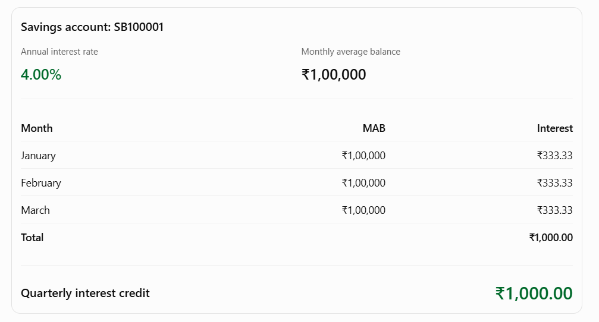
With the sample daily balances:
Savings account: SB100001
Annual interest rate

4.00%
Monthly average balance

₹1,00,000
Month | MAB | Interest
January | ₹1,00,000 | ₹333.33
February | ₹1,00,000 | ₹333.33
March | ₹1,00,000 | ₹333.33
Total |  | ₹1,000.00
Quarterly interest credit

₹1,000.00
Run:
SELECT fn_quarterly_interest(1, 2026, 1);
Expected result:
1000.00
Then:
CALL sp_credit_quarterly_interest(2026, 1);
Check the updated account balance:
SELECT
account_number,
balance,
interest_rate
FROM accounts
WHERE account_id = 1;
The original balance is ₹100,000. The quarterly credit adds ₹1,000, making the balance ₹101,000 before considering other transactions.
Note: The sample daily snapshots are historical examples and deliberately use a constant balance. In a real implementation, generate each day's snapshot from the actual end-of-day account balance, carrying forward the previous day's balance on days without transactions.

10. Important implementation improvements
Before using this schema in a real banking application, consider these changes:
Area | Recommended improvement
Password security | BCrypt or Argon2 password hashing
Account balance | Maintain a double-entry ledger
Fund transfer | Lock both accounts in consistent account-ID order
Transaction integrity | Implement idempotency and reversal transactions
Auditing | Record authenticated application user identity
Interest calculation | Support rate changes and product-specific rules
Daily snapshots | Schedule automated EOD balance generation
Login security | Account lockout and failed login tracking
Database access | Least-privilege database users
Financial precision | Use DECIMAL, never FLOAT or DOUBLE
Maturity | Add maturity settlement and account closure rules
Reconciliation | Periodically reconcile account balances against ledger entries
A couple of corrections to apply when using the script:
- MySQL may reject CURRENT_DATE inside a CHECK constraint because it is nondeterministic. Remove chk_customer_dob from the initial customer table definition and validate date of birth in the application or a trigger.
- The sample MATURITY transaction is a simple credit operation, not a complete fixed-deposit maturity settlement.
- The transaction audit table's foreign key prevents deleting an audited transaction. This is intentional for financial record retention.

11. Suggested Java JDBC project structure
This schema can be used as the foundation for a standalone banking CLI application.
banking-application/
│
├── src/main/java/
│ │
│ ├── config/
│ │ └── DBConnection.java
│ │
│ ├── model/
│ │ ├── Customer.java
│ │ ├── Account.java
│ │ ├── Transaction.java
│ │ └── LoginAudit.java
│ │
│ ├── dao/
│ │ ├── CustomerDAO.java
│ │ ├── AccountDAO.java
│ │ ├── TransactionDAO.java
│ │ └── LoginAuditDAO.java
│ │
│ ├── service/
│ │ ├── CustomerService.java
│ │ ├── AccountService.java
│ │ ├── BankingService.java
│ │ └── InterestService.java
│ │
│ ├── util/
│ │ ├── PasswordUtil.java
│ │ └── ValidationUtil.java
│ │
│ └── Main.java
│
└── database/
└── banking_database.sql

12. Recommended hands-on implementation sequence
For engineers learning SQL, JDBC and banking application development, I recommend implementing the database in this order:
- Phase 1 – Database fundamentals
- Create customers and accounts. Practice PK, FK, UNIQUE, CHECK and NOT NULL constraints.
- Phase 2 – SQL operations
- Implement customer registration, account creation, SELECT, INSERT, UPDATE and JOIN queries.
- Phase 3 – Banking transactions
- Implement deposits, withdrawals, fund transfers and transaction history using stored procedures.
- Phase 4 – Security and auditing
- Implement login auditing, transaction auditing, password hashing and account locking.
- Phase 5 – Interest calculation
- Implement daily snapshots, monthly average balance, quarterly interest functions and automatic credit.
- Phase 6 – Java JDBC integration
- Connect the database to Java using DAO, Service and Model layers. Implement transaction management and exception handling.
My recommendation: Keep this as the initial SQL learning and JDBC project, then introduce a double-entry ledger, transaction reversals and reconciliation as an advanced banking exercise. Those additions will make the project substantially closer to enterprise banking architecture.
I can also turn this into a complete hands-on banking database lab workbook with MySQL execution steps, expected outputs, SQL challenges and interview questions.

